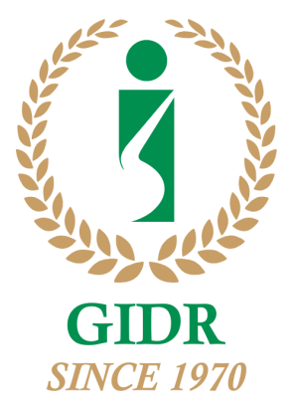
Celebrating 50 Years of Research and Academic Endeavour
Coffee value chains in India: Exploring sustainability oriented markets
Speaker: Prof. P.G. Chengappa
July 29, 2019, 3:30 PM, GIDR
Abstract
Indian coffee sector is at an important point of transition, wedged between quality and value segments of the market. The trend towards Robusta has reduced the share of Arabica coffee resulting in moving away from the quality segment of the market. The value chain analysis of conventional, certified, and organic coffee indicated that chains for coffee are largely diffuse in nature, with limited coordination in terms of quality and specifications in the conventional chain. Coordination is stronger in certified and organic chains, but incentives and motivation for upgrading largely stem from individual efforts to add value rather than those taking place at the chain-level. Clearly, organic and certified coffee proved to beneficial as compared to conventional coffee in terms of gains to the actors and sustainability point of view. There is a potential niche for India to develop eco-friendly coffees by leveraging the natural environment and biodiversity present in its coffee growing region Western Ghats, a hotspot of biodiversity. These suggest that integrating sustainability principles in a broad-based branding strategy could be difficult at the level of the chain without institutional support or the entry of chain champions. Acknowledgement : The authors thank the Research Funding Agency - Norwegian Research Council s NORGLOBAL and the Norwegian Institute of International Affairs (NUPI) for their contribution.

