***Book Launch***

**“Banaye Jeevan Pranavan”,**

**Eminent Author Shri Mukulji Kanitkar,**

**जीवन बनाएं प्राणवान"**

**मुकुल कानिटकर द्वारा रचित एक उत्कृष्ट कृति**

**@**

**Gujarat Institute of Development Research**

**Ahmdabad**

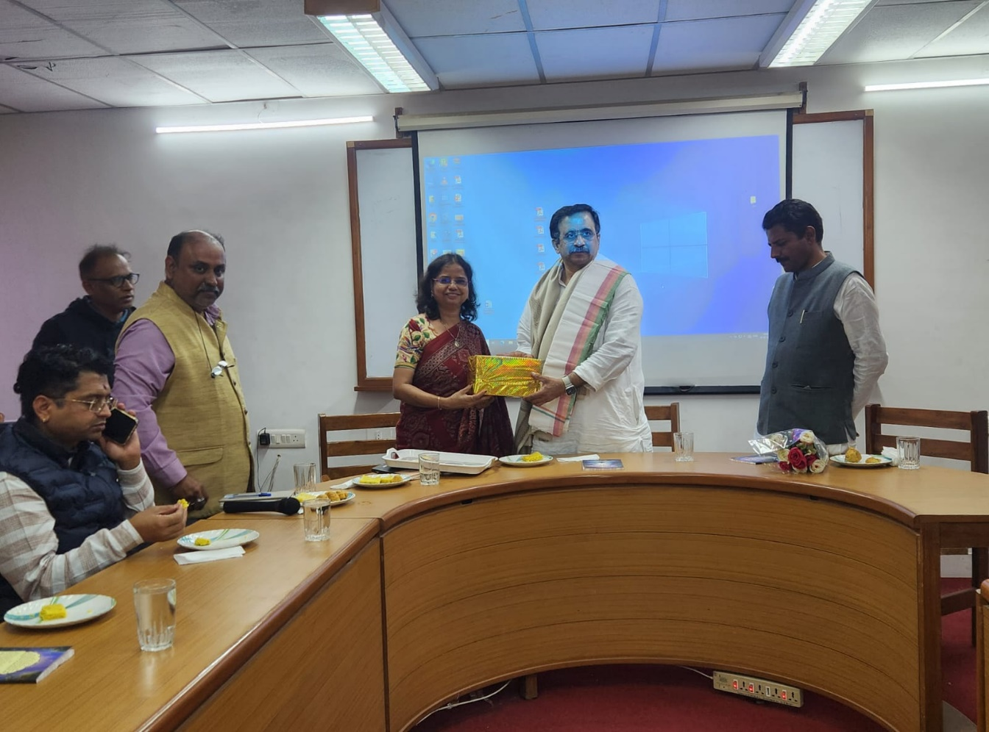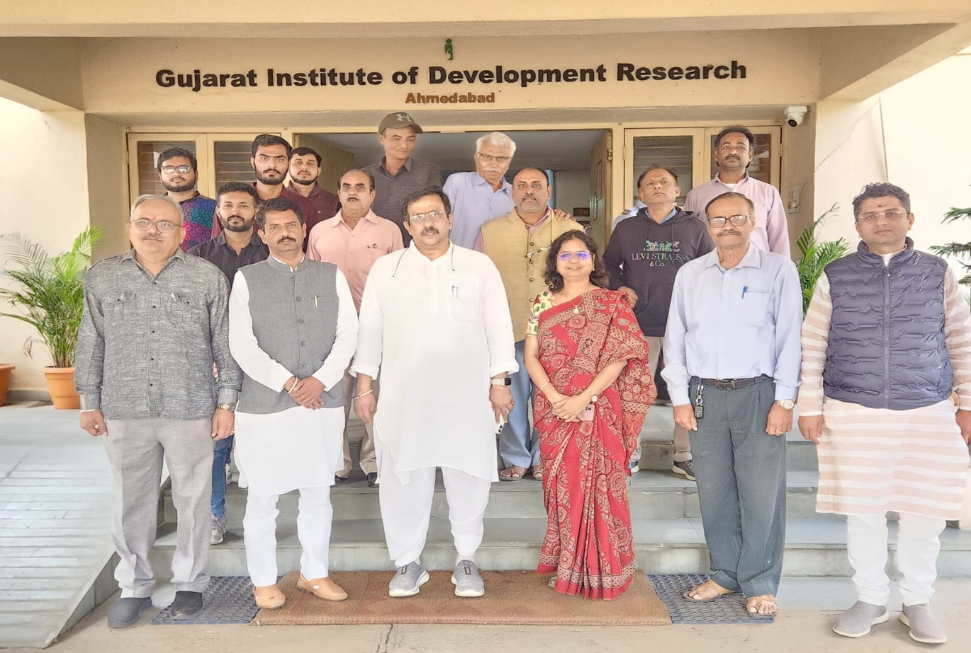

On January 20, 2025, at the Gujarat Industries Development Research (GIDR) premises, Gota Bridge, Sarkhej Road, Ahmedabad, a remarkable event was held. Eminent author Shri Mukulji Kanitkar, recognized for his book Banaye Jeevan Pranavan, graced the occasion. Shri Kanitkar is also known for receiving the Guinness World Record award for the Mass Surya Namaskar program held in Gwalior in 2005. During the program, he shared valuable insights and examples on creating a meaningful and successful life.

Dr. Nisha Pandey, Director of GIDR, provided a detailed introduction to the book Banaye Jeevan Pranavan. She highlighted that the book presents a holistic approach to life and emphasized that the author documented the essence of life after personally experiencing the "Pran Urja" (vital energy) through Surya Namaskar. Dr. Pandey underlined the unique process of experiencing, feeling, and then documenting, as described by the author. She elaborated on the profound philosophy of the book, mentioning Shri Mukul Kanitkar's reference to the stories of Prahlad and Hiranyakashyap. Prahlad symbolizes positive energy, while Hiranyakashyap represents negative energy, offering a valuable contrast that helps understand the dynamics of life (symbolized by the sun).

Dr. Pandey also highlighted the philosophical depth of the book, which draws inspiration from Ramayana. She discussed how the book embodies the principles of "Dharmo Rakshati Rakshitah" from Valmiki's Ramayana, emphasizing that following one’s duties fills life with energy and positivity. The book aims to guide readers toward purposeful living, balancing personal growth, societal responsibilities, and spiritual satisfaction.

Shri Mukul Kanitkar, during his address, shared insights from the book on how individuals can transform their lives with positivity, discipline, and energy. He shared the analogy of Prahlad, representing positive energy, and Hiranyakashyap, symbolizing negative energy, to convey the importance of choosing the path of righteousness and purpose. The book highlights the message that true success lies not in material possessions but in self-development, contributing to societal well-being, and living a life aligned with higher ideals.

The book Banaye Jeevan Pranavan was officially launched during the event under the esteemed presence of Dr. Nisha Pandey. She also delivered the welcome address and introduced the institute. The event was efficiently coordinated by Mr. Rudra, a member of the institute. The program was further enriched by the participation of several distinguished guests, including:

* Acharya Deepak Koirala, All India Gurukul, Bharatiya Shikshan Mandal
* Shri Devendraji Panwar, I View Enterprise, New Delhi
* Dr. Ajit Singh Rana, Professor of Education, Dr. Babasaheb Ambedkar University, Ahmedabad
* Mr. Mohit Raghuvanshi, Student at IRMA

Additionally, officials and employees of GIDR and progressive natural farmer Narendra Mandir from Gandhinagar were present. Mr. Mandir shared his knowledge on healthy eating habits to support a vibrant life.

The book’s central message is to lead a “Pranavan” (energy-filled) life, which emphasizes purpose, positivity, and societal contribution. It teaches readers that a life aligned with higher ideals, personal growth, and societal betterment is the key to true fulfillment. Drawing from the teachings of Ramayana, the book inspires readers to live with energy, enthusiasm, and a sense of responsibility toward the greater good.