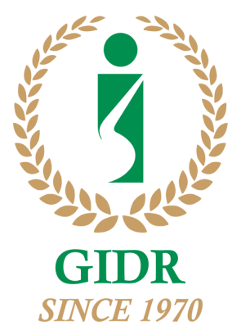
Celebrating 50 Years of Research and Academic Endeavour

Dear All,

Greetings from Gujarat Institute of Development research (GIDR), Ahmedabad.

It is my privilege to let you know that GIDR is celebrating its Golden Jubilee (June 2019-June 2020). As part of the Golden Jubilee celebration, GIDR has planned to organize several academic events throughout the year 2019-20.

Prof. P G Chengappa, Former Vice Chancellor, University of Agricultural Sciences, Bangalore, will be delivering the first lecture as part of GIDR’s Golden Jubilee Lecture Series, on “Coffee value chains in India: exploring sustainability oriented markets” at 3:30 PM on Monday, July 29, 2019 at Lakdawala Hall, GIDR.

On behalf of GIDR, I am happy to invite you all to the lecture. I request you to kindly share this invitation with your scholars/students, as well. I keenly look forward to your participation in the discussion. Your reflection and suggestions would enrich the discussion session.

I have enclosed a short biography of Prof. P.G. Chengappa along with the abstract of his lecture for your ready reference.

Looking forward to seeing you at GIDR on July 29, 2019 at 3:30 PM.

Thank you.
Best regards.

Dr. Amrita Ghatak
Coordinator of Discussion Series at GIDR
&
Assistant Professor
Gujarat Institute of Development Research, Ahmedabad

